**Assignment 13**

**Problem statement**: Create a WorkMail for your organization.

The step are as follows: -

1. Navigate to the AWS console and locate the "Work Mail" service. Click on the first option that appears in the search results

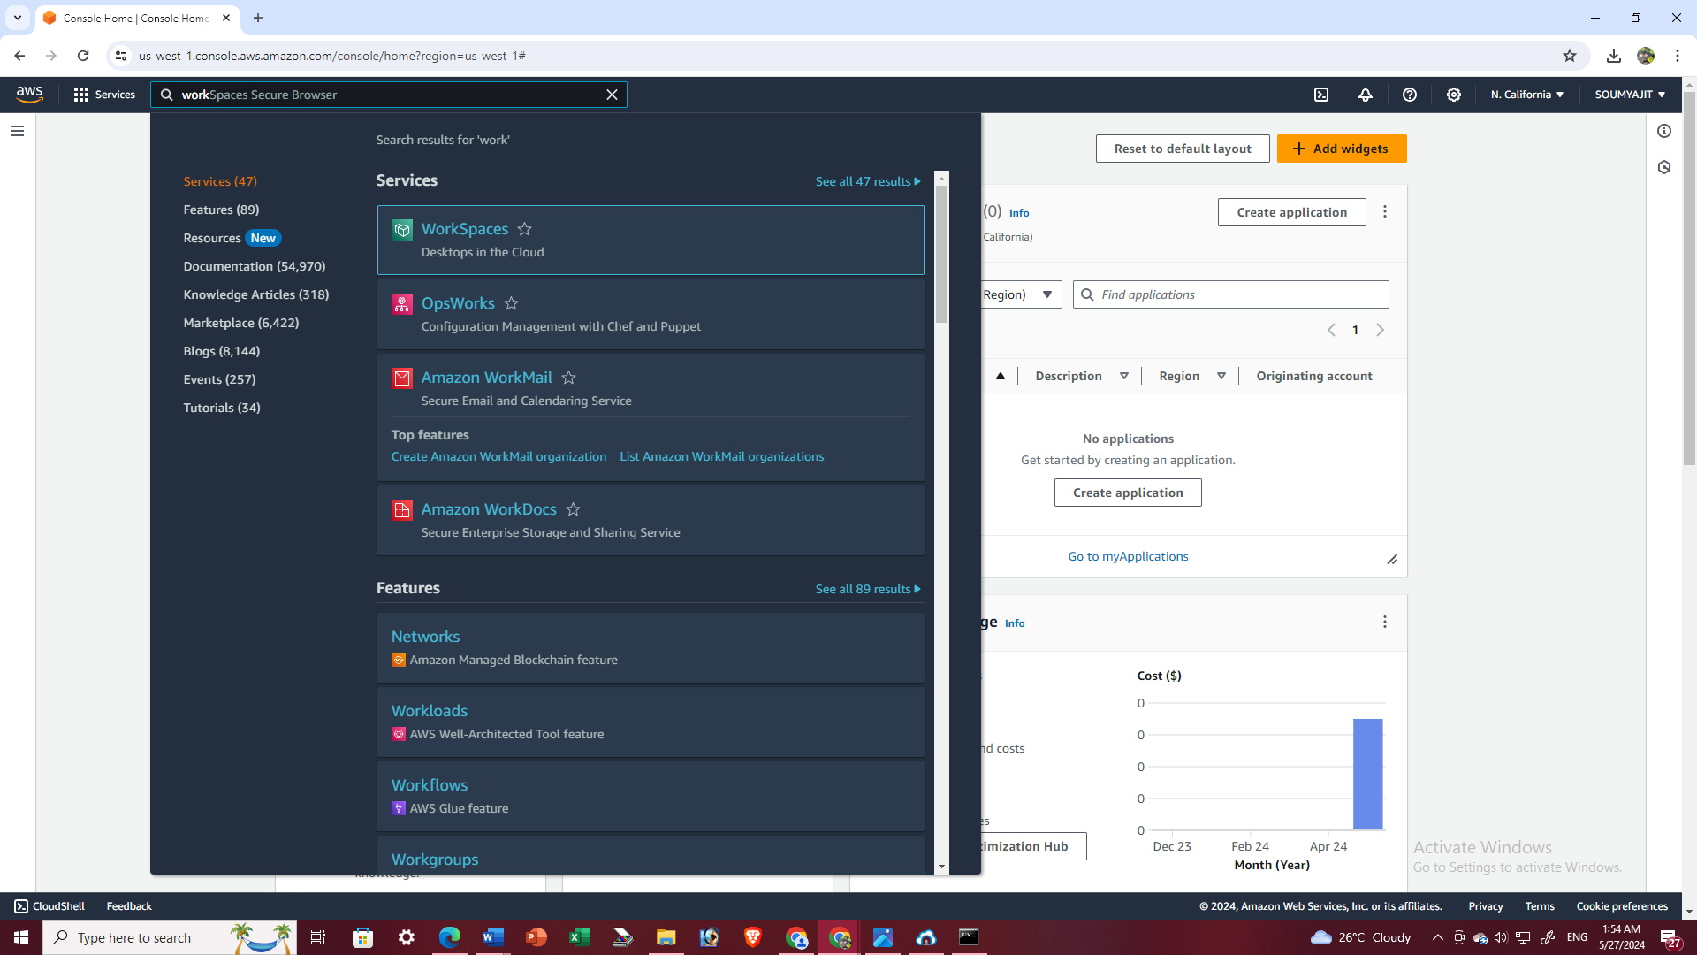

1. Region Asia(Mumbai) is not supported. So chose N.Virginia as region. Then click on “Create organization”.

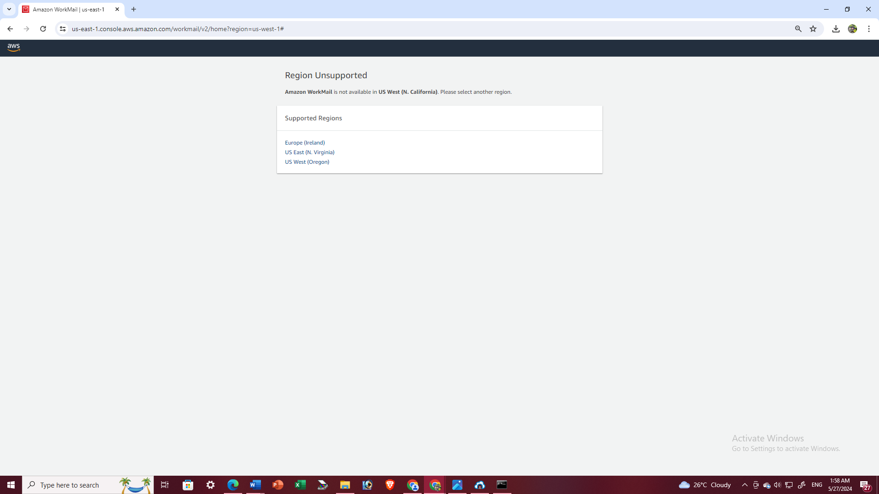

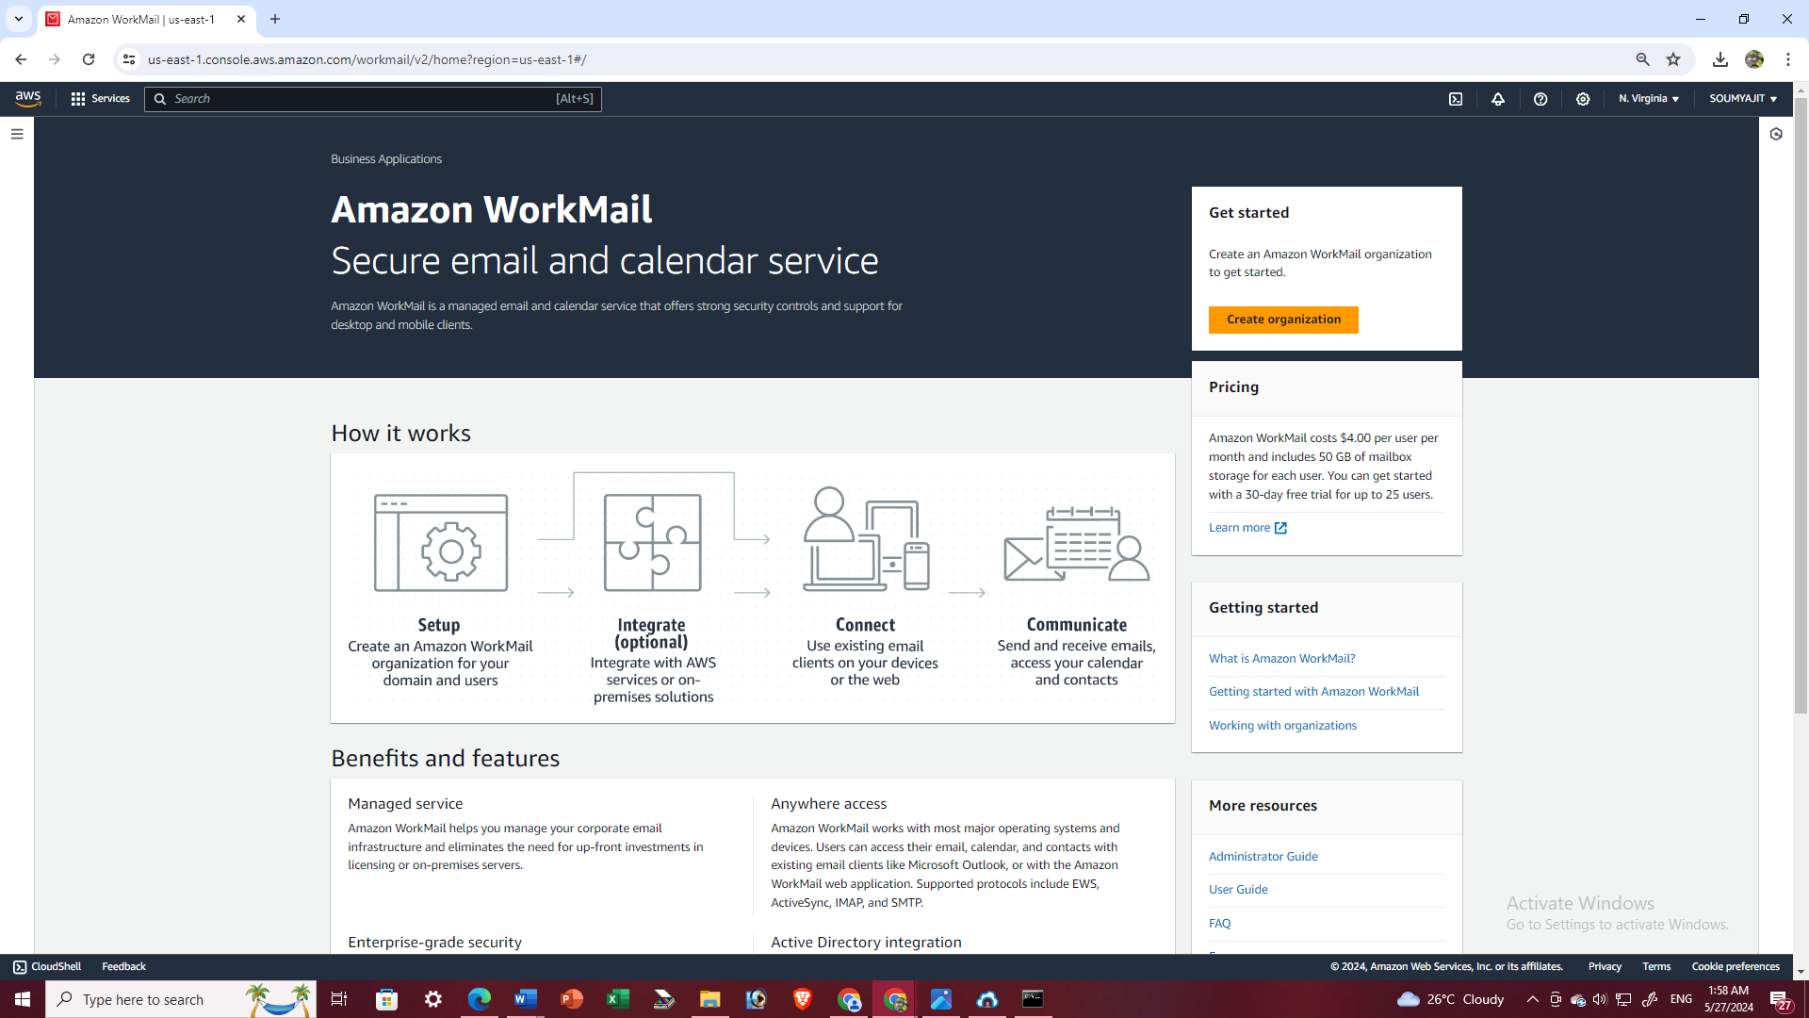

1. Select the "Free test domain" option from the available email domains. Then, enter an organization name, such as "mckvie5."

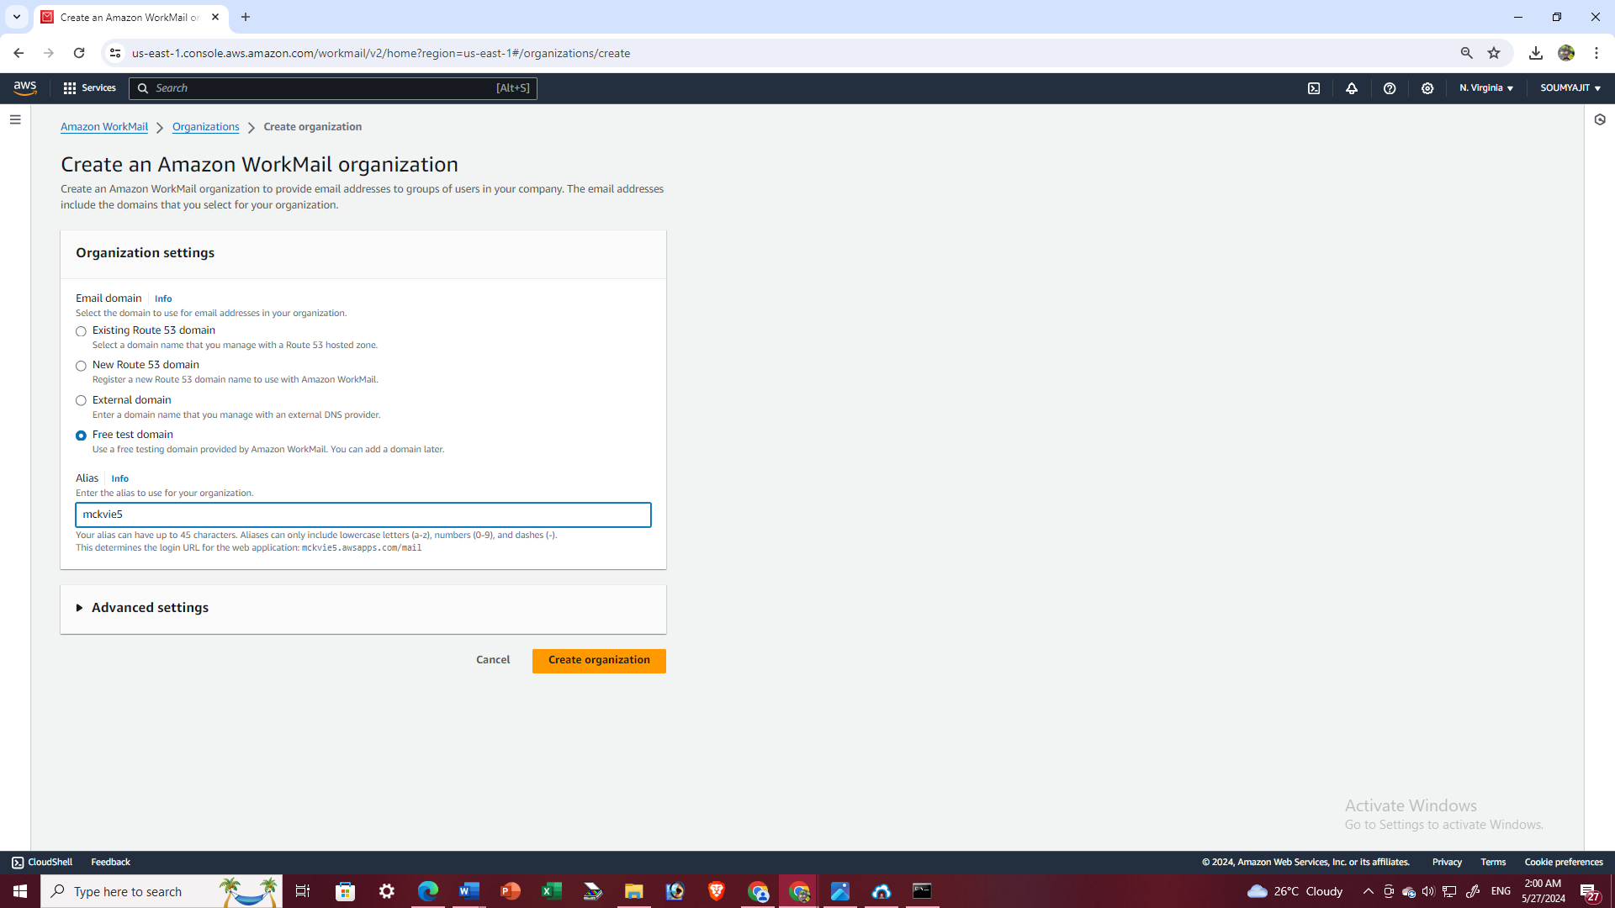

1. Organization created successfully. Once the organization is successfully created, click on the organization name

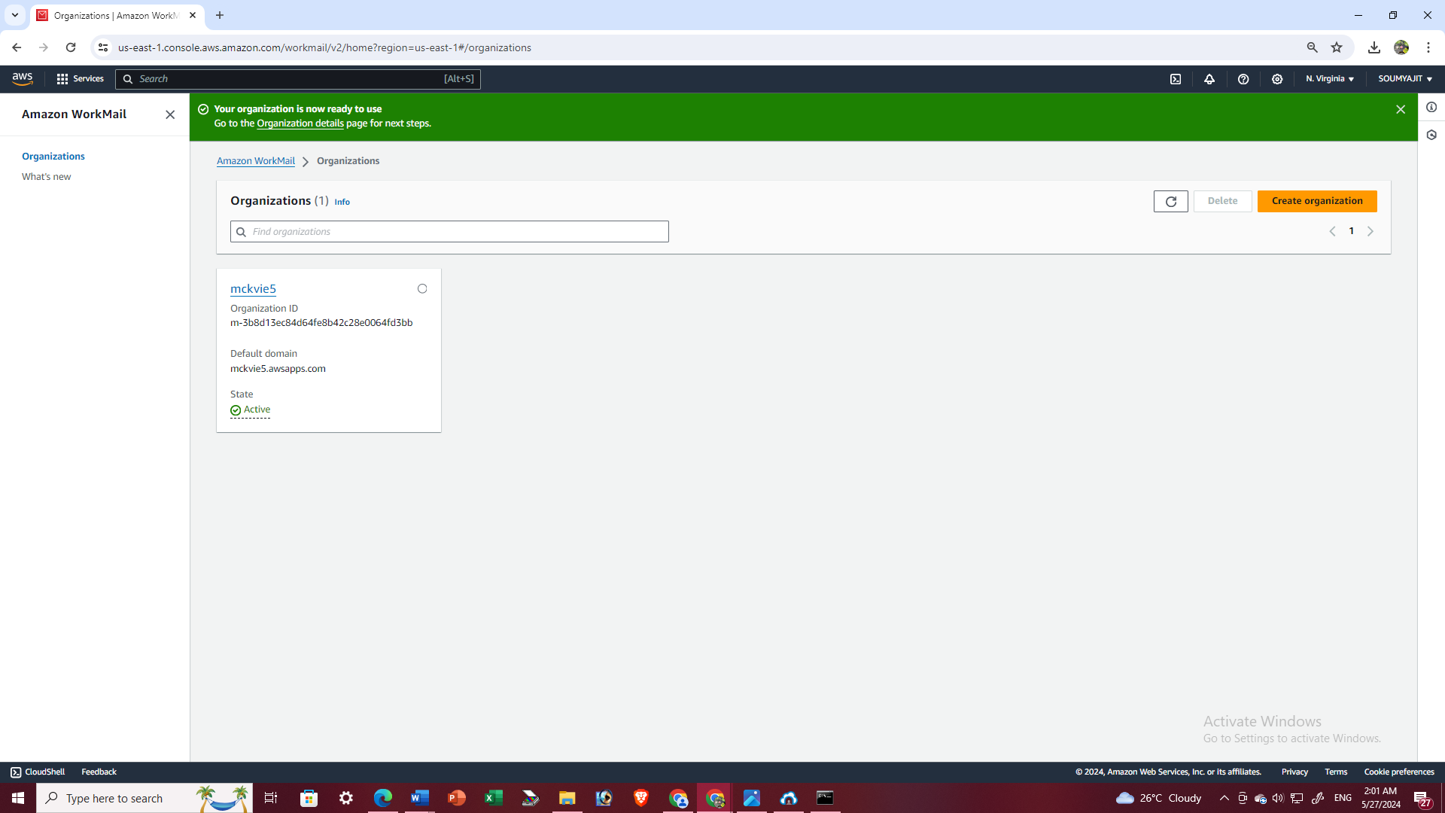

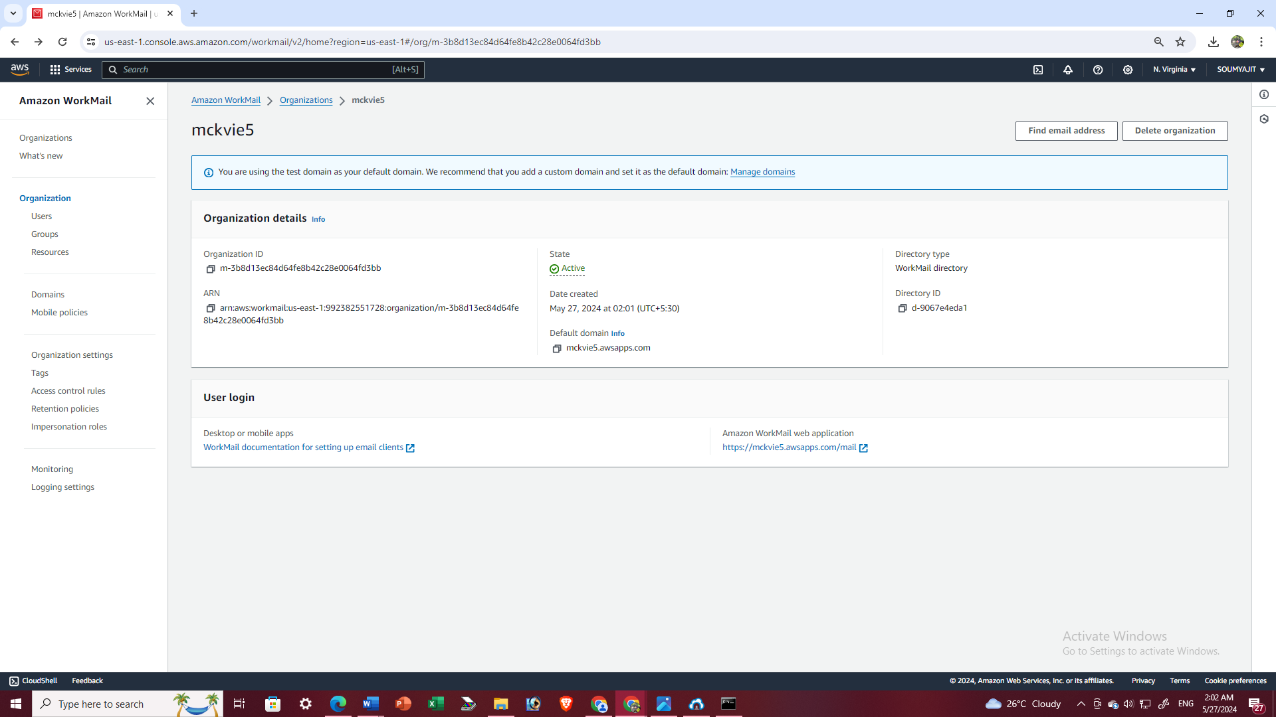

1. From the left pane, navigate to "Users" under the Organization category. Then proceed to click on “Add user”

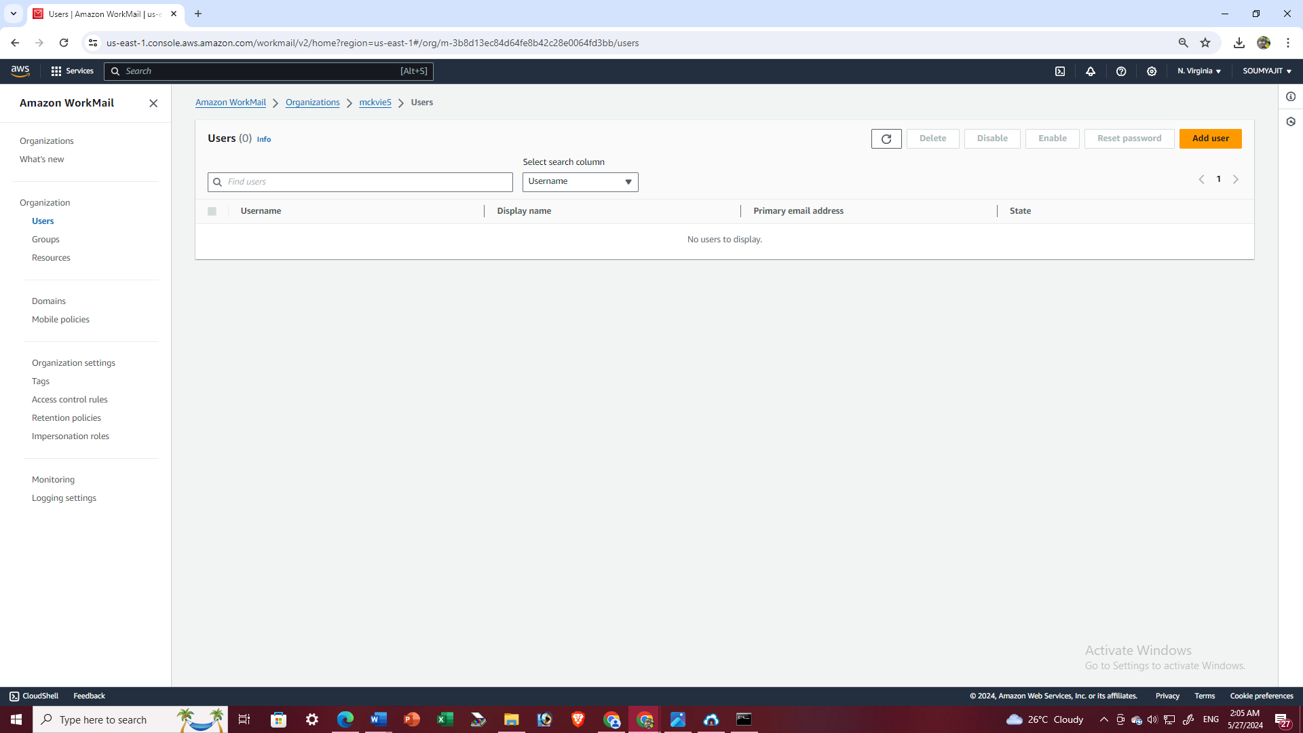

1. Enter the username, first name, and last name in their respective fields. The display name will be generated automatically. Next, set a password for the WorkMail account according to the provided guidelines. Then proceed to click on “Add User”

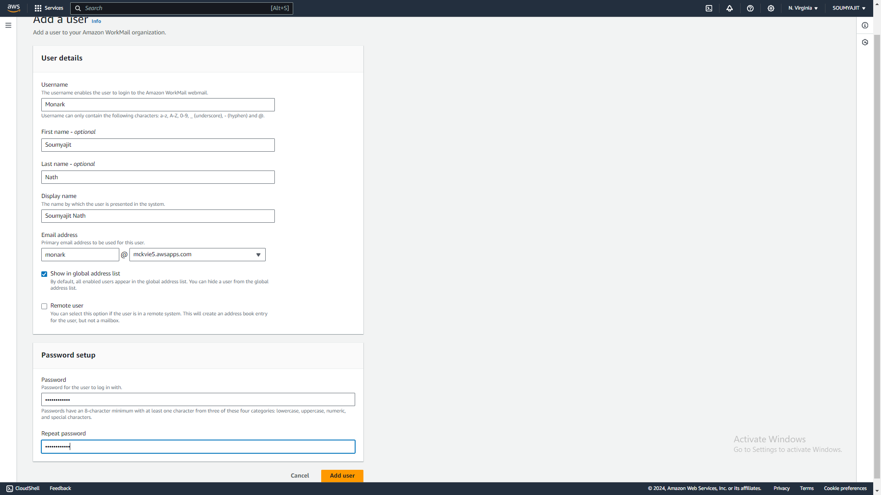

After successfully adding the user, return to the organizations page, click on the organization name, and navigate to the “Amazon WorkMail web application” link to proceed.

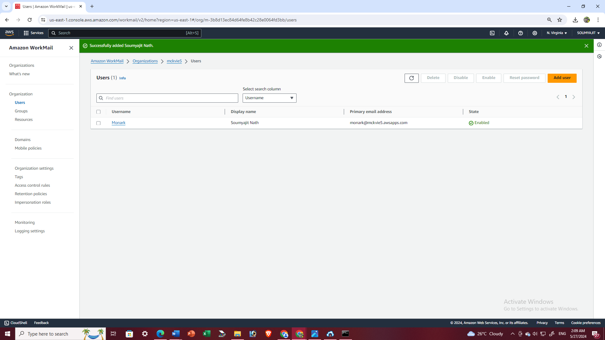

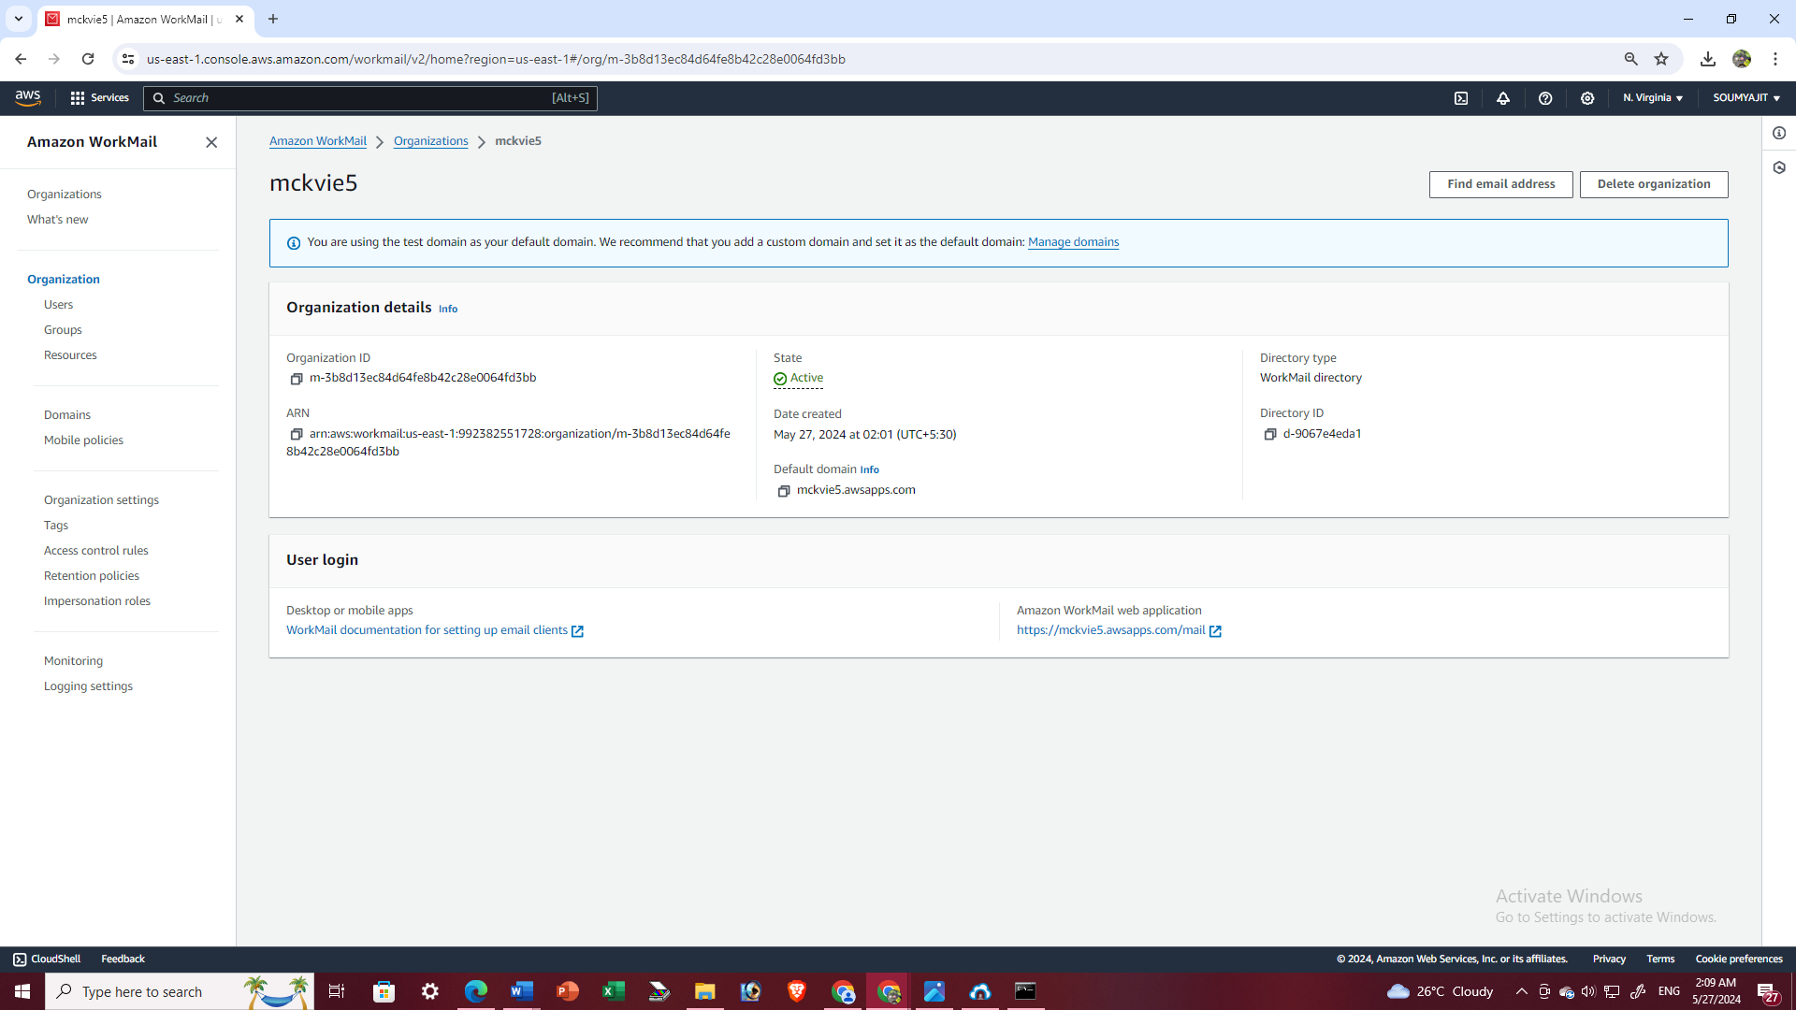

Now, enter the username and password to access WorkMail account

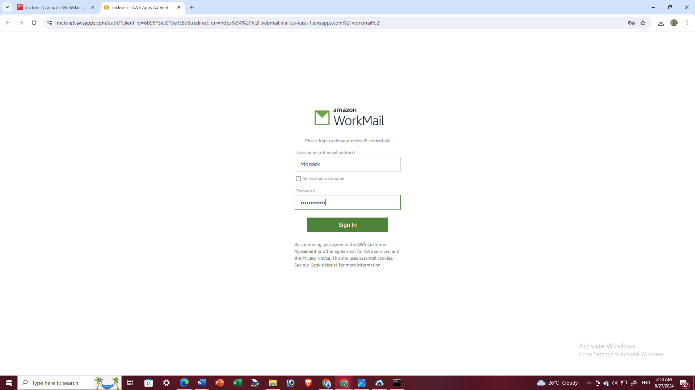

From this point,we can send an email to a Gmail account and verify whether it was received in our Gmail inbox to confirm that our WorkMail is functioning properly.

